Report Dimension Table Techniques

by Aliaksandr Labayeu

# Task 1 - Geo Hierarchy

Location hierarchy was built on the basis of 4 pre-configured (in Task 01) dimensions:

World 🡺 Region 🡺 County 🡺 City

Description:

* **Child and Parent** ID was prepared manually. They are the main filed that helps to provide hierarchy dependencies.
* **Hierarchy** filed helps up to visualize existing hierarchy with the help of ‘spaces’
* **Path** shows the dependency between location grains
* **Level** – Oracle’s feature that helps to investigate what is the level of the row in the hierarchy
* **Tree** – field was built with the help of DECODE fuction on the basis of level of the hierarchy where 1st level is the lowest level – root, then goes two branches and the highest level called Leaf

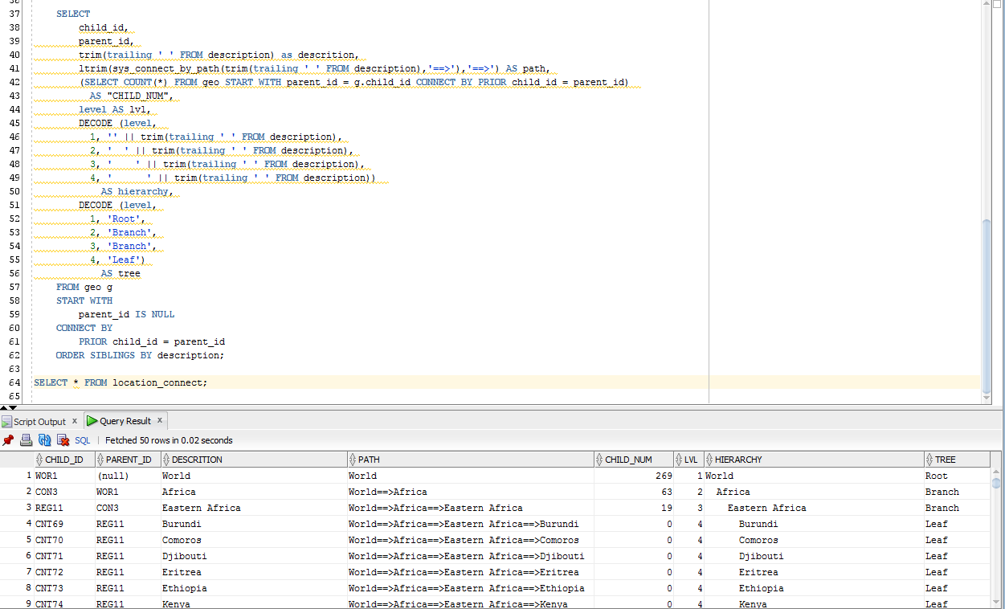

# Task 2 - Dimension Hierarchy Analysis

There is a dim_department in PMI Data Warehouse which include 3 location filed that can be involved in hierarchy:

Region 🡺 Country 🡺 City

Appropriate changes was made so as to make future insert into dim_department:

